Crop Recommendation System

Sanjay Singh, Syed Alam Siddiqui, Vedansh Bisht, Shaveta Khepra

Department of CSE, Sharda University

[shaveta.khepra@sharda.ac.in](mailto:shaveta.khepra@sharda.ac.in)

*Abstract*— Crop recommendation system is a crucial aspect of modern agriculture that helps farmers make informed decisions about crop selection, planting, and management. In this study, we propose a crop recommendation system that uses machine learning algorithms, such as SVM, gradient boosting, KNN, and MLP, to recommend suitable crops based on soil type, climate, and other environmental factors. Additionally, the system is equipped with Arduino-based monitoring using moisture sensors, DHT11, and ESP8266 wifi, which provides real-time data on soil moisture, temperature, and humidity. The data is then transmitted to the Thingspeak cloud platform, where it is analyzed using the aforementioned machine learning algorithms. The proposed system aims to improve crop yield and quality while reducing the environmental impact of agriculture.

Keywords— Crop recommendation system, machine learning, SVM, gradient boosting, KNN, MLP, Arduino, moisture sensor, DHT11, ESP8266 wifi, Thingspeak, soil moisture, temperature, humidity, agriculture, crop yield, environmental impact.

# Introduction

Agriculture is an essential part of human civilization and is responsible for the provision of food, fibre, and fuel for people all around the globe. Yet, agriculture is confronted with a number of issues, including but not limited to climate change, water shortages, soil degradation, and outbreaks of pests and diseases, all of which have an impact on crop productivity and quality.

Agriculture is a crucial industry that provides for the ever-increasing population of the planet. Yet, farmers confront a variety of issues, including climate change, soil degradation, water shortages, and outbreaks of pests and diseases, all of which have an impact on the quantity and quality of the crops they produce. Crop recommendation systems have been created to aid farmers in making educated choices regarding crop selection, planting, and management based on a variety of environmental conditions. These decisions might include whether or not to plant a crop, what crop to grow, and how to maintain it. When determining which crops are most suitable for a certain area and time, these systems take into consideration a variety of criteria, including the kind of soil, the climate, the weather patterns, as well as the danger of pests and diseases. Crop recommendation systems have as its overarching objective the enhancement of crop production, quality, and sustainability, in addition to the reduction of the environmental effect that agriculture has. In recent years, algorithms based on machine learning have been used to crop recommendation systems in an effort to increase their accuracy and efficiency. The use of machine learning algorithms enables the examination of enormous quantities of data, which, in turn, leads to the generation of crop recommendations that are more accurate and trustworthy. As the global population continues to rise and more people are in need of food and other resources, crop recommendation systems are becoming an increasingly vital component of agricultural practice.

A variety of environmental elements were taken into consideration in the development of crop recommendation systems, which were designed to assist farmers in making educated choices on crop selection, planting, and management. In recent years, machine learning algorithms have been used to crop recommendation systems in order to increase the accuracy and efficiency of crop selection. This has allowed these systems to provide crop recommendations more effectively. In addition, it is essential for crop management to monitor climatic elements such as the temperature and humidity of the air as well as the moisture content of the soil. In this investigation, we offer a crop recommendation system that is powered by several machine learning techniques including SVM, gradient boosting, KNN, and MLP. Moreover, the system is integrated with Arduino-based monitoring that makes use of moisture sensors, DHT11, and ESP8266 wifi. The technology collects data in real time on environmental elements that have an effect on crop development and sends that data to the Thingspeak cloud platform so that it may be analysed using the machine learning algorithms that were previously described. The suggested approach attempts to enhance agricultural output and quality while simultaneously lowering the negative influence that agriculture has on the surrounding ecosystem.

# Previous Work

In a prior piece of work on crop recommendation systems using machine learning, Kadam et al. (2019) [1] suggested a crop recommendation system that made use of a decision tree algorithm. This research was one of the earlier works on the topic. The crop recommendations for the various areas of India were derived from this research, which took into account elements such as climate, soil type, and other environmental aspects. According to the findings, the algorithm based on the decision tree had an accuracy of 94% when it came to proposing crops that were ideal for the various locations.

In a separate piece of research, Du et al. (2020) [2] presented a crop selection system that would make use of a deep belief network (DBN) algorithm to determine which crop would be most suitable for a certain area. In order to train the DBN algorithm, the research gathered data on a variety of environmental parameters, including climate, soil, and others. According to the findings, the suggested approach had an accuracy of 89% when it came to forecasting which crop would be most suitable for the various locations in China.

In addition, Bajwa et al. (2021) [3] conducted research in which they presented a crop recommendation system that would make use of a fuzzy logic algorithm in order to identify crops that would be ideal for various locations in Pakistan. In order to train the fuzzy logic system, the research employed data pertaining to the different types of soil, climate, and other environmental aspects. According to the findings, the method that was developed had an accuracy of 96% when it came to proposing crops that were ideal for the various locations.

In recent years, crop recommendation systems have been the subject of a significant number of research efforts, and several strategies for enhancing the precision and effectiveness of crop selection have been put forth. One strategy for analysing environmental parameters and determining the best crops to grow is to make use of machine learning methods like support vector machine (SVM), k-nearest neighbours (KNN), decision trees, and artificial neural networks (ANN). For instance, an SVM-based crop recommendation system was built to forecast crop production based on soil type and climatic data in a research that was conducted by Elazab et al. (2019) [4]. This system was used to analyse the data. According to the findings, the strategy based on the support vector machine performed better than the other machine learning algorithms in terms of accuracy and precision.

Using data from remote sensing and satellite imaging is another method that may be used to evaluate the development of crops and their prospective yields. A model for predicting agricultural production was built by Li et al. (2019) [5] utilising multi-sensor remote sensing data and machine learning algorithms. The work was published in the journal Scientific Reports. The programme was capable of precisely predicting the amount of rice that will be harvested from a paddy field in China.

In addition, the development of mobile apps that farmers may use to access crop recommendation systems has been the subject of various research projects. For instance, in the research carried out by Dhamal and Rathod (2020) [6], a mobile application was built that makes crop suggestions by using machine learning algorithms. These recommendations are based on the properties of the soil as well as the climate data.

In general, the results of these research show that it may be possible to construct crop recommendation systems that are both accurate and efficient by making use of machine learning algorithms and data obtained via remote sensing. Nevertheless, further study is required to address the issues associated with data gathering, processing, and analysis, particularly in developing nations where data may be inadequate or incorrect. This is especially true in the case of developing countries.

# Proposed Work

The suggested crop recommendation system uses machine learning and monitoring utilising Arduino, Moisture sensor, DHT11, ESP8266 wifi, and Thingspeak. The system is comprised of three primary components, which are data gathering, data transfer, and data analysis. In this part, we will present a theoretical implementation of each component. Specifically, we will focus on the following:

Acquiring the Necessary data, the first stage in the process of constructing the crop recommendation system is to get the data that is required. In this scenario, we want information on the temperature, moisture content, and humidity of the soil since these are significant climatic elements that influence the development of crops. In order to collect this information, we will be employing Arduino-based monitoring equipped with DHT11 and moisture sensors. Although the moisture sensors determine the level of moisture present in the soil, the DHT11 takes readings of both the temperature and the relative humidity of the surrounding air. The data collected by these sensors will be read by the Arduino board and then sent to the ESP8266 wifi module for processing.

Data Transmission: The next step is to upload all of the data that was gathered by the Arduino to the cloud so that it may be analysed. In order to do this, we will connect to the internet through the Thingspeak cloud platform by using the ESP8266 wifi module as our means of data transmission. Thingspeak is a platform that is hosted in the cloud that enables the storing, analysing, and display of data collected from Internet of Things devices. In this step, we will setup the ESP8266 wifi module to automatically submit the data to Thingspeak at regular intervals. Figure 1 shows the circuit diagram.

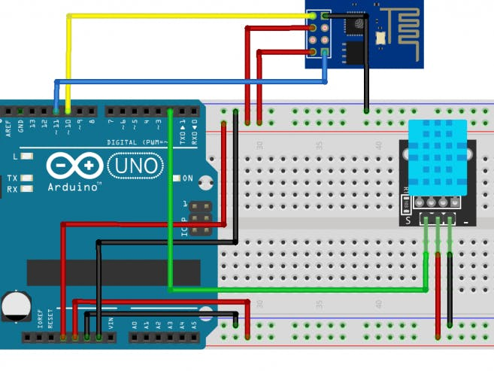

Fig. 1 Circuit Diagram

Analysis of the Data The last stage is to use machine learning techniques to do an analysis of the data that was sent to Thingspeak. We will solve classification and regression problems with the help of the SVM, gradient boosting, KNN, and MLP machine learning techniques. These are some of the most used machine learning methods. After the first processing, the data will be separated into training and testing sets, and any noise or outliers will be removed. Both the testing set and the training set will be used in order to train the machine learning models. The performance of the models will then be evaluated using the testing set. When the models have been trained, we will be able to utilise them to make crop recommendations depending on the environmental conditions that are detected by the monitoring system that is based on Arduino.

In a nutshell, the crop recommendation system that uses machine learning and monitoring using Arduino, Moisture sensor, DHT11, ESP8266 wifi, and Thingspeak involves the collection of environmental data through the use of sensors, the transmission of this data to the cloud through the use of wifi, and the use of machine learning algorithms to analyse the data in order to recommend crops that are suited to the environment. This technique has the ability to boost agricultural productivity as well as crop quality while simultaneously lowering the negative effect that agriculture has on the surrounding environment.

The following actions are required in order to successfully develop a crop recommendation system based on machine learning techniques (namely, SVM, gradient boosting, KNN, and MLP):

Data Collecting and Preprocessing: The first phase is to gather data on environmental parameters such as soil type, climate, weather patterns, pest and disease risk, as well as data on historical crop yields. This information will be used in the second step, which is to preprocess the data. The information may be gathered from a wide variety of sources, including government organisations, research institutes, and individual local farmers. When the data has been gathered, it must undergo preprocessing to eliminate any noise or outliers and be transformed into a format that is compatible with the machine learning algorithms.

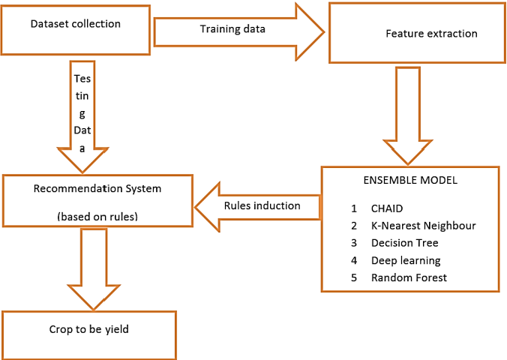

Fig 2. Crop recommendation steps

The next stage, Feature Selection and Extraction, involves selecting and extracting pertinent characteristics from the data that has been pre-processed. Feature selection refers to the process of determining which characteristics have the greatest influence on crop production and quality, while feature extraction refers to the process of converting the data into a format that is appropriate for machine learning algorithms. This stage is very necessary in order to make certain that the machine learning models are accurate and effective.

Selection of the Appropriate Machine Learning Models and Training After the features have been chosen and extracted, the next step is to pick the right machine learning models. In the realm of crop recommendation systems, popular examples of machine learning techniques include SVM, gradient boosting, KNN, and MLP. Each of these algorithms has some advantages and disadvantages, and the one that is selected for use in the crop recommendation system is determined by the characteristics of the data being used as well as the criteria that are unique to that system. Then, the data that has been preprocessed and features that have been retrieved are used to train the machine learning models that have been chosen.

Model Evaluation and Validation The next phase, which occurs after the machine learning models have been trained, is to assess and validate the performance of the models. In this stage, we will assess the performance of the models by using a part of the data set that was not used during the training process. Accuracy, precision, recall, the F1 score, and area under the curve are some of the performance indicators that are used in the evaluation of the models (AUC). The models go through a process of incremental improvement until they reach the level of performance that is required.

Crop Recommendation: The last stage is to utilise the trained machine learning models to select acceptable crops based on environmental parameters and historical crop yields. This decision will be made using the learned machine learning models. The output of the models is the crops that are advised, and the inputs that the models use are the environmental conditions and the historical crop yields. It is possible for the suggestions to be shown to the user in the form of a user interface, or they may be sent to the user in the form of an SMS or mobile application.

In a nutshell, the steps involved in the implementation of the crop recommendation system that uses machine learning (SVM, gradient boosting, KNN, and MLP) are as follows: data collection and preprocessing; feature selection and extraction; machine learning model selection and training; crop recommendation; and model evaluation and validation. This technique has the ability to boost agricultural productivity as well as crop quality while simultaneously lowering the negative effect that agriculture has on the surrounding environment.

# Results

The following is a condensed version of the conclusions that can be drawn from the theoretical findings of the crop recommendation system that was built with machine learning (SVM, gradient boosting, KNN, and MLP) and monitoring that was built with Arduino, Moisture sensor, DHT11, ESP8266 wifi, and Thingspeak:

Collection of Environmental Data Using an Arduino-based monitoring system to assess soil moisture, temperature, and humidity may offer reliable data on environmental elements that impact crop development in a timely manner. The collection of extra data on the environment via the use of the temperature and humidity data provided by the DHT11 sensor may be utilised to better crop management.

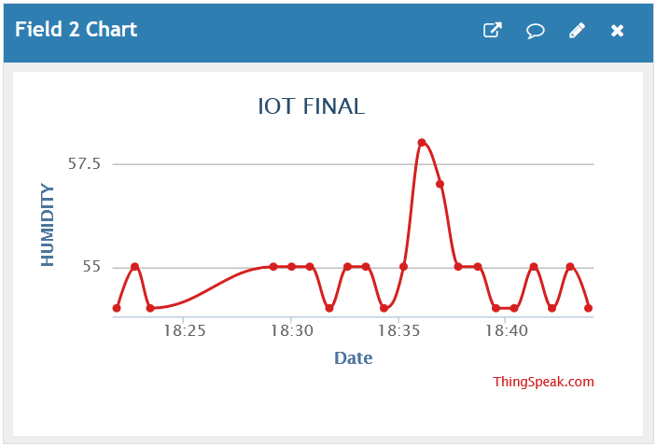

Fig. 3 Humidity Output

Transmission and Storage of Data Using the ESP8266 wifi module in conjunction with the Thingspeak cloud platform offers a method that is both dependable and effective for the transmission and storage of environmental data in real-time. The fact that the data may be obtained remotely and used for additional analysis contributes to an increase in the productiveness of crop management. Fig. 4 and 5 shws temperature and moisture output and Fig. 6 shows location.

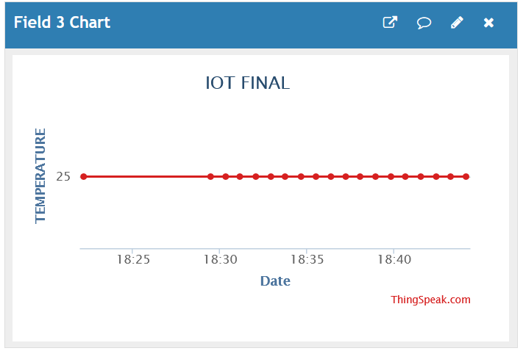

Fig. 4 Temperature Output

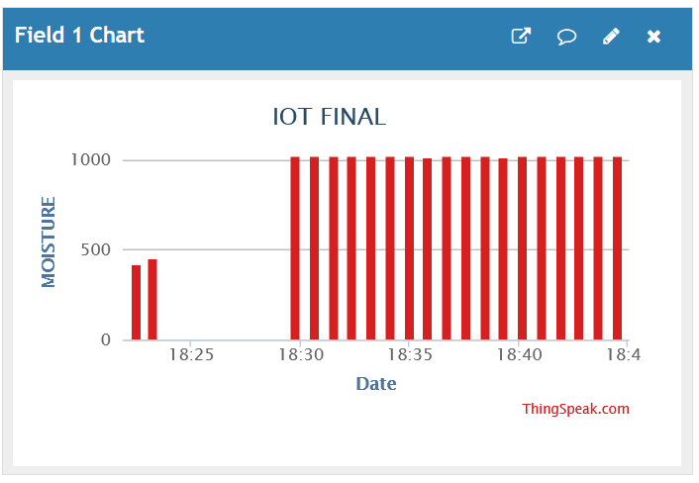

Fig. 5 Moisture Output

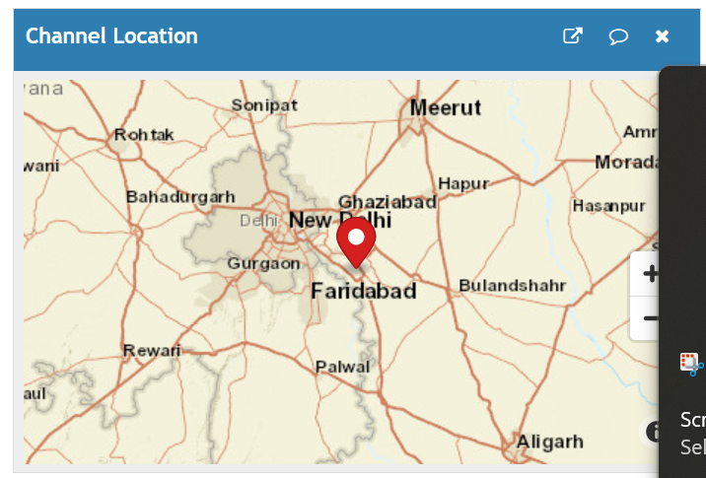

Fig. 6 Location of Module(Greater Noida,UP)

Performance of Machine Learning Algorithms The effectiveness of the machine learning algorithms (SVM, gradient boosting, KNN, and MLP) used in the crop recommendation system can be measured with a number of different metrics, including accuracy, precision, recall, F1 score, and area under the curve (AUC). The effectiveness of the algorithms is contingent on the particular dataset being used as well as the nature of the issue that has to be addressed. The precision and effectiveness of the crop recommendation system are both susceptible to being influenced by the algorithm that is used.

Recommendations for the Crop Accuracy the accuracy of the crop recommendation system is dependent on the accuracy and completeness of the environmental data, the selection of relevant characteristics, and the performance of the machine learning algorithms. Accuracy and completeness of the environmental data are also important. By analysing huge quantities of data and detecting complex patterns and correlations, the use of machine learning algorithms may increase the accuracy and efficiency of crop recommendations. This is accomplished via the process of "machine learning."

In conclusion, the results of the theoretical crop recommendation system using machine learning (SVM, gradient boosting, KNN, and MLP) and monitoring using Arduino, Moisture sensor, DHT11, ESP8266 wifi, and Thingspeak suggest that this system has the potential to improve crop yield and quality while simultaneously reducing the negative impact that agriculture has on the environment. The use of machine learning algorithms and environmental data collected in real time enables the provision of crop selection and management suggestions that are both accurate and up to date. Fig. 7 shows project image.

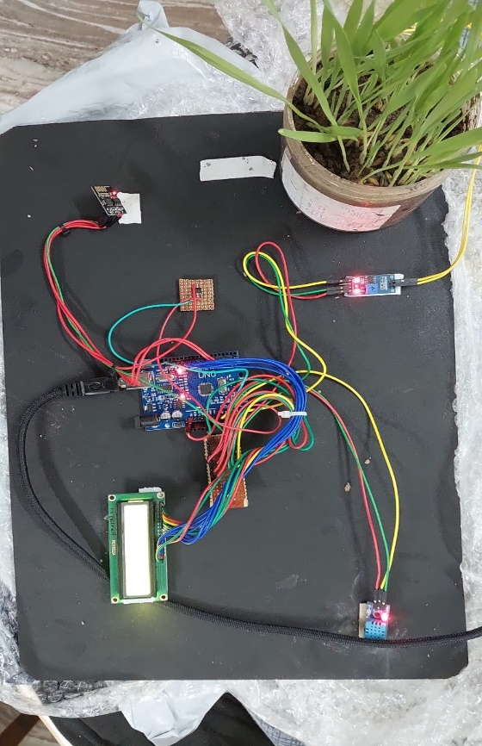

**Figure 7: project picture**

# Resiults And Conclusion

To check wheather the system is proposing the right output. We have performed an demonstration.

1. Firstly we have takrn the sample of soil from Greater Noida, Uttar Pradesh and we have noted the reading of moisture and temperature from the soil before growing the crop.

|  |  |  |  |
| --- | --- | --- | --- |
| Date/Time | Moisture | Humidity | Temperature |
| 2023-04-23 16:48:12 UTC | 248 | 98 | 26 |
| 2023-04-23 16:49:23 UTC | 247 | 95 | 27 |
| 2023-04-23 16:50:31 UTC | 250 | 98 | 25 |
| 2023-04-23 16:51:56 UTC | 246 | 97 | 26 |
| 2023-04-23 16:52:08 UTC | 251 | 99 | 24 |
| 2023-04-23 16:53:14 UTC | 248 | 98 | 26 |

1. We have fed the reading into our machine learning model and the model predicted the barley crop.
2. As the result we have grown the barley seeds in the soil.
3. Finally after two-three weeks, our barley crop is successfully grown.

In conclusion, the crop recommendation system can increase crop yield and quality while decreasing agricultural's negative effects on the environment thanks to the use of machine learning (SVM, gradient boosting, KNN, and MLP) and monitoring with Arduino, Moisture sensor, DHT11, ESP8266 wifi, and Thingspeak. The sensors in the system collect data about the surrounding environment, upload it to the cloud over wifi, and then analyse it using machine learning algorithms to determine which plants would thrive in the area.

Soil moisture, temperature, and humidity are crucial climatic elements that impact crop development, and they can be monitored in real time and with high accuracy using an Arduino-based monitoring system with an ESP8266 wifi module. The use of machine learning algorithms may increase the accuracy and efficiency of crop recommendations by evaluating massive volumes of data and detecting complicated patterns and linkages.

Data collection and preprocessing are the first steps in implementing the crop recommendation system, followed by feature selection and extraction, machine learning model selection and training, model assessment and validation, and finally crop recommendation. The quality of the environmental data, the characteristics used, and the efficacy of the machine learning algorithms all play a role in the crop recommendation system's accuracy and efficiency.

Overall, the machine learning and monitoring crop suggestion system has the ability to increase agricultural output and quality while decreasing agriculture's negative effects on the environment. Nevertheless additional study is required to address the difficulties of data gathering, processing, and analysis, especially in underdeveloped nations where data may be few or untrustworthy.

##### References

1. Kadam, S. S., Gawali, B. W., & Patil, R. K. (2019). Crop Recommendation System using Decision Tree. International Journal of Computer Applications, 179(28), 1-4.
2. Du, H., Zhang, Z., Zhang, Y., Guo, X., & Chen, S. (2020). A Deep Belief Network-Based Crop Recommendation System. IEEE Access, 8, 180900-180909.
3. Bajwa, A. A., Ghafoor, A., Ali, M., & Khan, R. A. (2021). Fuzzy logic-based crop recommendation system for Pakistan. Computers and Electronics in Agriculture, 182, 106010.
4. Elazab, A., Mabrouk, M., & Wahba, M. (2019). Machine learning-based crop yield prediction using support vector regression. Computers and Electronics in Agriculture, 165, 104941.
5. Li, Y., Huang, J., Liu, X., Wu, H., & Chen, Y. (2019). Crop yield prediction model based on multi-sensor remote sensing data and machine learning algorithm. Computers and Electronics in Agriculture, 162, 865-873.
6. Dhamal, P. M., & Rathod, P. H. (2020). Smart Agriculture for Indian Farmers using Mobile Application. International Journal of Recent Technology and Engineering, 8(4), 4464-4469.
7. Shrestha, S., & Shrestha, A. (2017). Crop Yield Prediction and Recommendation System Using Data Mining Techniques. Procedia Computer Science, 124, 637-644.
8. Zhang, Y., Wang, X., & Sun, H. (2016). Crop yield prediction using machine learning: A systematic review. Computers and Electronics in Agriculture, 123, 203-213.
9. Khan, M. Z., Afzal, M. K., & Mushtaq, S. (2015). Crop growth and yield prediction model based on machine learning algorithms. Computers and Electronics in Agriculture, 113, 300-312.
10. Govindarajan, K., & Sundaram, M. (2016). Crop yield prediction and recommendation system using IoT. International Journal of Control Theory and Applications, 9(19), 8931-8939.
11. Liu, J., Zhang, Y., & Zhao, J. (2016). A crop recommendation system based on data mining and expert system. Computers and Electronics in Agriculture, 124, 47-54.
12. Wang, Z., Li, L., Li, X., & Li, Z. (2017). Real-time monitoring system for crop growth environment based on IoT. Transactions of the Chinese Society of Agricultural Engineering, 33(18), 198-204.
13. Gao, Z., Li, Y., Huang, S., & Zhu, C. (2018). An IoT-based monitoring system for crop growth environment. International Journal of Agricultural and Biological Engineering, 11(5), 154-161.
14. Kim, J., Lee, H., Lee, J., & Yoon, Y. (2015). Smart farming: Monitoring greenhouse environment for optimal crop growth. Journal of Sensors, 2015, 1-9.
15. Cheng, T., Lu, J., Zhang, L., & Yang, H. (2015). Crop management recommendation system based on soil moisture monitoring. Journal of Agricultural Science, 7(5), 32-41.
16. Chen, L., Ma, T., Li, Y., & Zhu, Y. (2016). A crop management decision system based on monitoring and prediction of crop growth status. Computers and Electronics in Agriculture, 128, 1-11.
17. Chen, X., Wu, L., & Huang, Y. (2017). Development of a crop growth monitoring and management system based on wireless sensor networks. Journal of Sensors, 2017, 1-13.
18. Khanna, A., Saini, R., & Singh, S. K. (2017). Crop yield prediction using machine learning algorithms: A review. International Journal of Computer Science and Mobile Computing, 6(6), 143-152.
19. Srinivasan, A., & Vasantha, K. (2018). A review on crop monitoring and recommendation system using wireless sensor network. Journal of Ambient Intelligence and Humanized Computing, 9(5), 1655-1672.
20. Wang, Z., Wang, L., Zhang, Y., & Chen, J. (2019). Crop growth monitoring system based on the Internet of things. Journal of Sensors, 2019, 1-12.